Firebase authentication

Firebase is a platform that allows the development of web and mobile applications without server-side programming and it provides a series of built-in services. Firebase Authentication is very easy and quick to implement, has autoscaling built-in and provides real-time updates. It automatically stores users’ credentials securely by using bcrypt and it separates this sensitive user information from the application’s data.

Setting up Firebase is a very intuitive, fast and easy process. Everything was set up by using a google account, creating a new project and adding a new app to it. For the authentication, the email/password sign-in method was enabled.

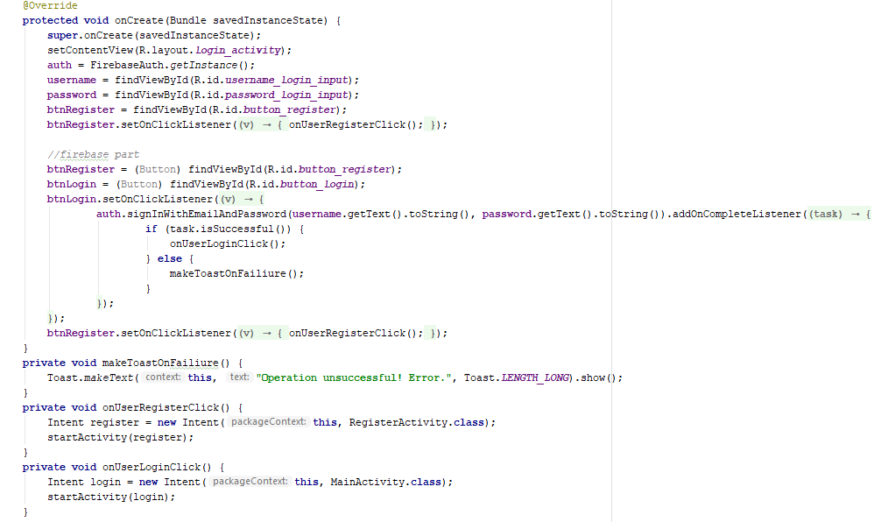The main activity opens the app in the login screen where existing users can log in and new users can register. The logic behind the login activity and its connection to Firebase can be observed in the screenshot below.

Figure Logic behind the Login activity

The layout is set for this activity and the input fields and the buttons are identified. For the Register button an on click listener is attached which runs the method that opens the Register activity.

When the login button is pressed, the user data from the input fields is compared to the Firebase database and if the user was registered, the Main Activity opens up. Otherwise, an error message will be displayed on the screen.

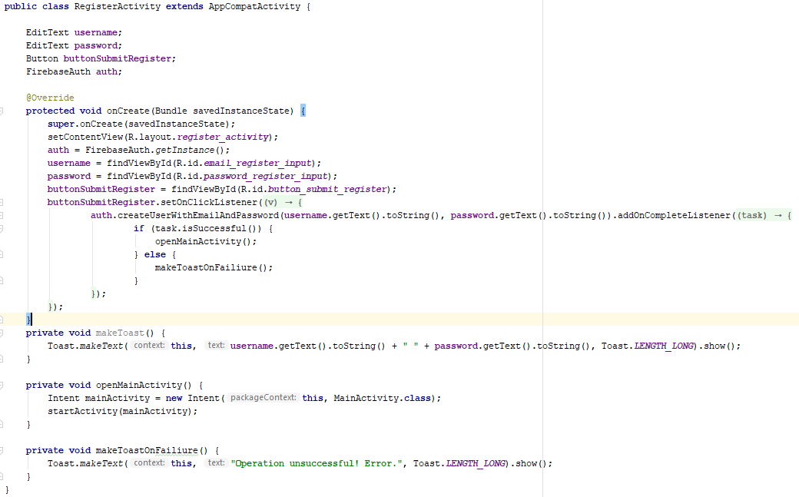The logic behind the Register activity is presented in the image below. Once the Firebase connection has been established and the layout was set, on the press of the “submit register” button, the user credentials are sent to the Firebase database and the Main activity starts. In the eventuality of a failed registration, an error message is displayed on the screen.

Figure Logic behind the Register activity